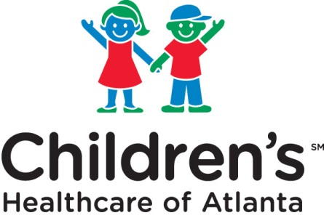
Clinical Research Department
Phone: 404-785-7555 Fax: 404-785-9470
Email: irb@choa.org
choa.org/clinicalresearch
For faster processing, please submit form via email or fax. Submit only once (via one method).

IRB AUTHORIZATION AGREEMENT (IAA)
RELIANCE ACKNOWLEDGEMENT FORM

--CLOSE-OUT--

This form is for use in studies that are being closed out that have an IRB Authorization Agreement (IAA) with another institution, or when your research falls under the umbrella agreement with Emory, Georgia Tech, or Morehouse. Please contact the IRB if you need assistance determining whether or not you should complete this form.

To be completed by study staff:
Project Title:
Principal Investigator:
PI Email:
IRB Number from approving institution:
Study Coordinator or Contact Person:
Contact Email:
Contact Phone:
Has a conflict of interest been identified in this study? |  |  | Yes No

Signature of Principal Investigator or Coordinator Date

Acknowledged By:

Children’s Healthcare of Atlanta Representative Date

For studies that include patient care at Children's , this documentation does not imply all requirements for the Office of Sponsored Programs have been me. Please notify the Office of Sponsored Programs of this closure.

