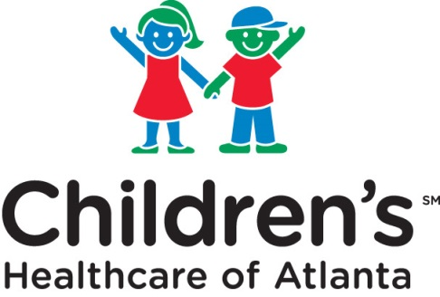 **Institutional Review Board**

Phone: (404) 785-7555 Fax: (404) 785-9470

For faster processing, please submit form via email or fax. Please submit only once, via one method.  
 [irb@choa.org](mailto:irb@choa.org)

<http://www.choa.org/clinicalresearch>

# DECEDENT RESEARCH

***Note: This form should only be used where the study involves only decedent information. It should not be used if your study collects both decedent and non-decedent information.***

Research protocols involving decedents do not require IRB review. However, based upon federal regulations for HIPAA at 45 CFR 46.160 and 164, a review by the Institution's Privacy Board is required for access to health information of decedents. At Children’s, the IRB also serves as the Privacy Board.

1. **PROJECT INFORMATION**

|  |  |
| --- | --- |
| Title of Proposal: | |
| Principal Investigator: | Department: |
| Telephone: | Fax: |
| Email: |  |

I understand that the approval of this request is contingent upon my agreement:

1. That the use or disclosure is sought is solely for research on the protected health information of decedents;
2. That the protected health information for which use or disclosure is sought is necessary for the research purposes;
3. That documentation of the death of such individuals will be provided at the request of Children’s;
4. That the protected health information will not be used or further disclosed;
5. That the protected health information will not be publicly identified;
6. That the protected health information will be safeguarded to prevent further use or disclosure; and
7. That contact will not be made with the personal representative or family members of the decedent.

Will you need identifiers of the deceased or their relative, employer or household members?

Yes  No

If **No**, please sign below.

If **Yes, what PHI will be used:**

I certify that I will carry out the proposed data collection in compliance with the principles stated above.

Signature of Principal Investigator Date