Create a New Study:
- On the “My Inbox” page (this should also be your home page), click the “Create New Study” button on the left side of your page.
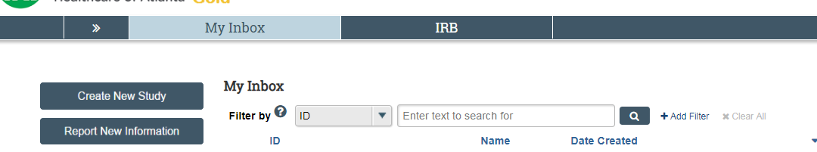

- Basic Study Information:
  - Input basic study information as prompted. Be sure to click on the question mark buttons for further clarification.
  - When attaching protocol, please also be sure to also attach the protocol summary if the study is multisite.

- Funding Sources:
  - Add a funding source if applicable. If the funding source is not in the system, please contact the IRB at 404-785-7555 or at Meredith.Capasse@choa.org
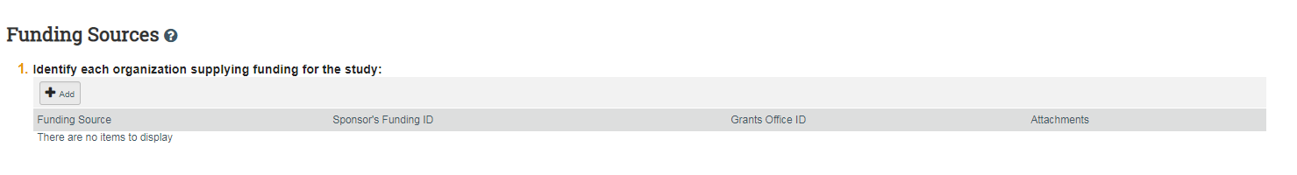

- Study Team Members:
  - In section 1, click “Add” to add study members and fill out information as prompted by the pop-up window. If a study team member has a CHOA network ID and cannot be found in the eIRB system, please contact the IRB at 404-785-7555 or at Meredith.Capasse@choa.org
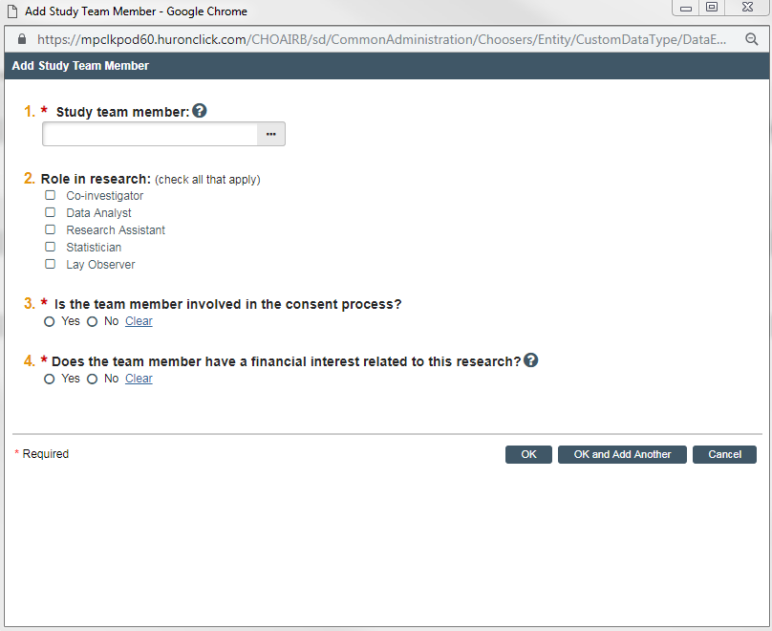
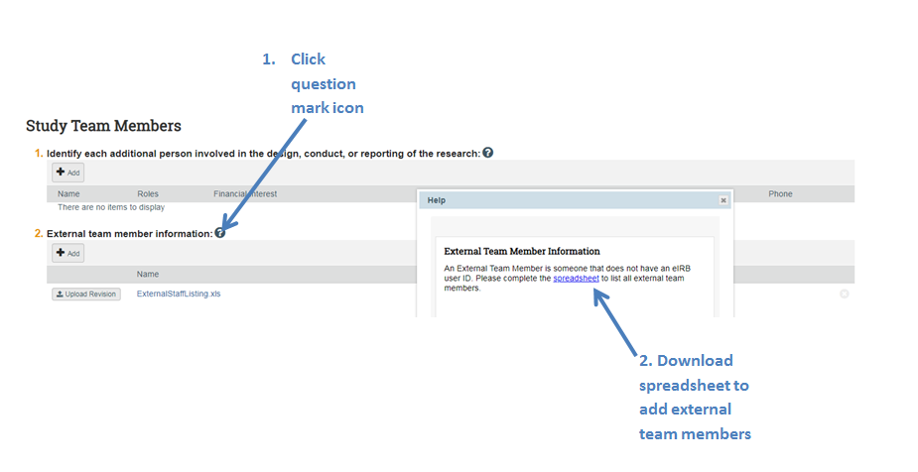
  - In section 2, please add all external (those who do not have a CHOA network ID) study team members using the external team member spreadsheet. To access the spreadsheet, click on the question mark icon and click on the spreadsheet link in the pop up window.

- Study Scope – Answer questions as prompted.
- Local Research Locations
  - Add all local research locations. Click the ellipses to see if the research location is already in the system.
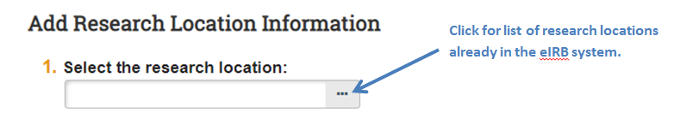

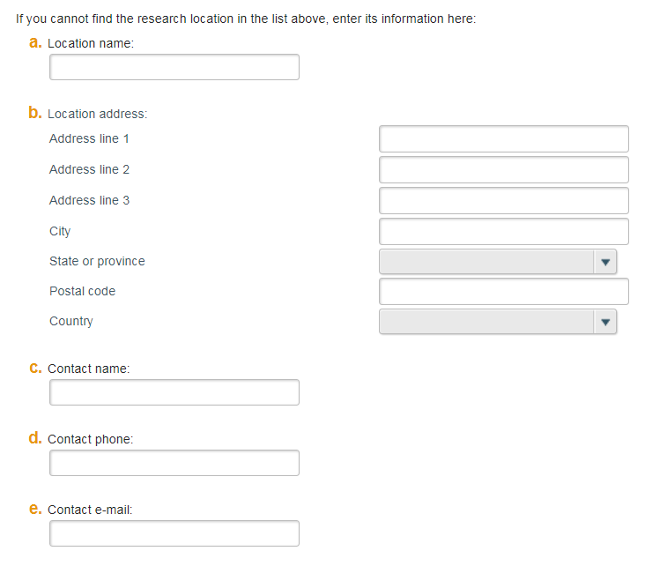
  - If the research location is not in the eIRB system, fill out the bottom section of the pop up window as best you can.

- Drug Information (if applicable)
  - This section will appear if you indicated that a drug will be used in the “Study Scope” section.
  - Provide drug name, IND information (if applicable), and any supporting documents, such as Investigator’s Brochures, FDA letters, etc. 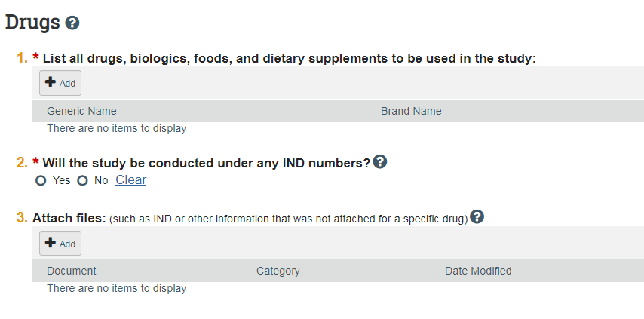
- Device Information (if applicable)
  - This section will appear if you indicated that a device will be used in the “Study Scope” section.
  - Provide device name, IDE information, and any supporting documents (manuals, FDA letters, etc.).
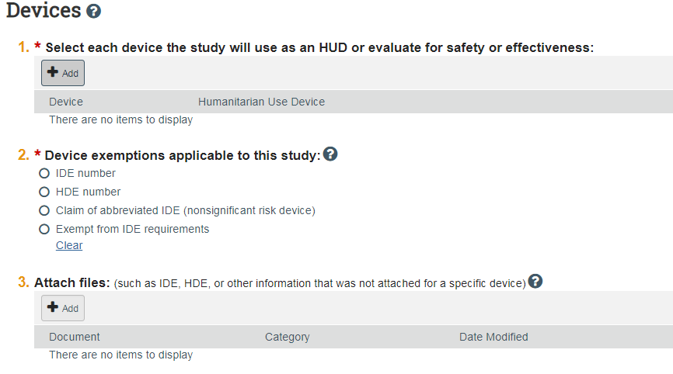

- Local Site Documents
  - In section 1, include consent documents (informed consent form, assent, revocation letter etc.)
  - In section 2, add recruitment materials if applicable. This would include recruitment letters, flyers, etc.
  - Other Attachments
    - Attach departmental approval here. This is required. If you also have approvals from outside departments, please also include here. This applies if you are enrolling subjects for your study from a department that is not your own (i.e. enrolling subjects that are not your patients).
    - Attach any other documents that are relevant to the study (questionnaires, DSMB reports, departmental approvals, outside department approvals, etc.)
- To submit your study:
  - Review the submission form to make sure information is correct and all relevant documents have been attached.
  - Click “Finish” on the last page of the submission form. You will be redirected to the main page of the study.
  - Important: On the main study page, please be sure to click “Submit” on the left side of the page. Your study will not be submitted to the IRB if you do not click “Submit”. To double check that the study has been submitted, the study status should note that the study is in Pre-Review.
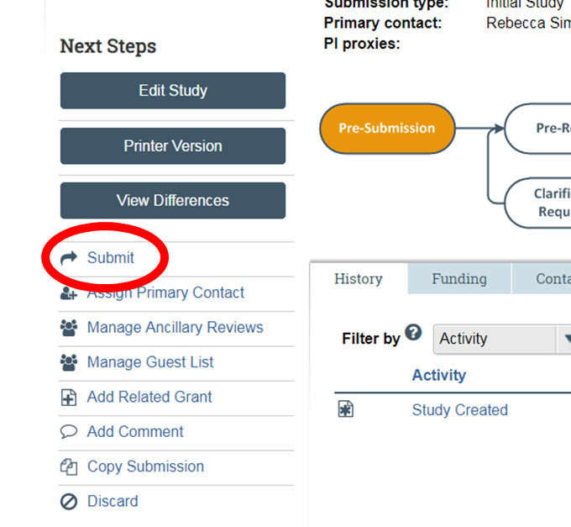

Submitting a Modification:
- Go to the main page for the study requiring modification.
- On the left side of the page, click “Create Modification/CR”. Please note that if you already have an open modification, you cannot submit a new modification until the open modification has been approved or withdrawn.
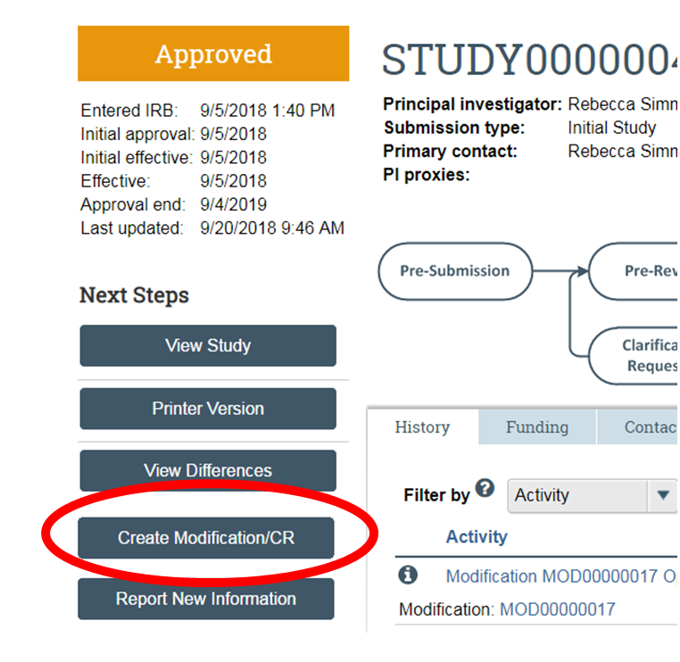

- Select “Modification/Update” and select the scope of your modification (you can select both scopes if applicable).
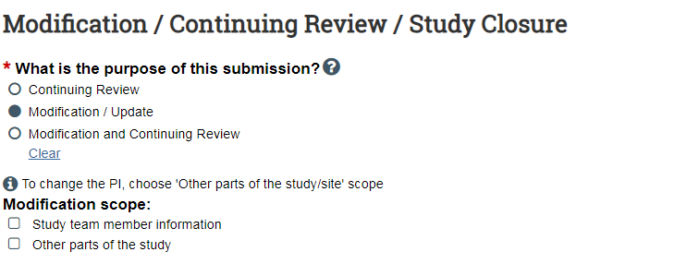
- Fill out the Modification Information page.
  - Please note that sections 1 and 2 of this page are not required. You can skip these sections if they are not relevant to the modification.
  - In section 3, please be sure to list all changes being made to the study as part of the modification.
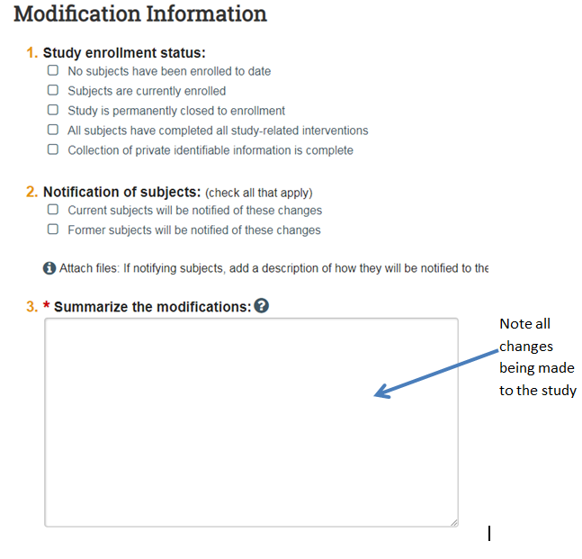

- The modification will now take you through every page of your initial submission form. Make the modifications where applicable.

*** If updating study documents that have already been approved, please be sure to click the “Update” button next to the currently approved document to add the new version of the document. If updating an approved document for the first time, update the approved document with a clean version of the document and add a tracked version. The tracked version can be updated with subsequent tracked versions for future updates.
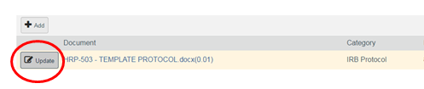

- To submit your study:
- Review the modification form to make sure information is correct and all modifications have been made.
- Click “Finish” on the last page of the modification form. You will be redirected to the modification page of the study.
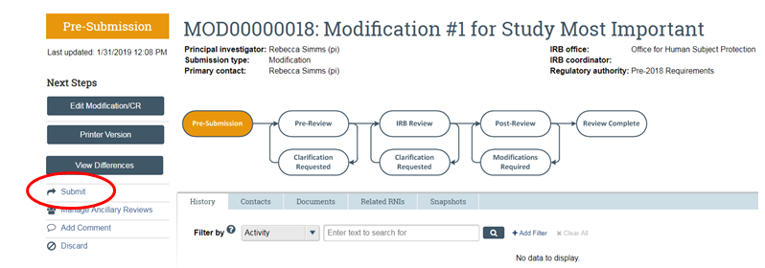
- Important: On the main modification page, please be sure to click “Submit” on the left side of the page. Your study will not be submitted to the IRB if you do not click “Submit”.

