Study Close-Out in eIRB
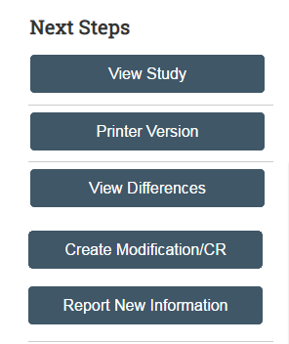
- In the study workspace, click the “Create Modification/CR” button on the left side of the screen.

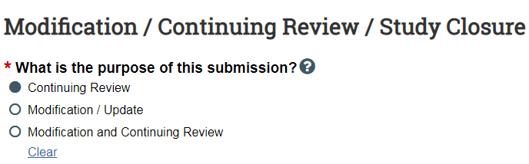
- When prompted to provide the purpose of the submission, click “Continuing Review” and continue with the smartform.

- Complete the Continuing Review/ Study Closure Information section of the submission form.
  - To close a study, the first four “Research Milestone” must be selected.
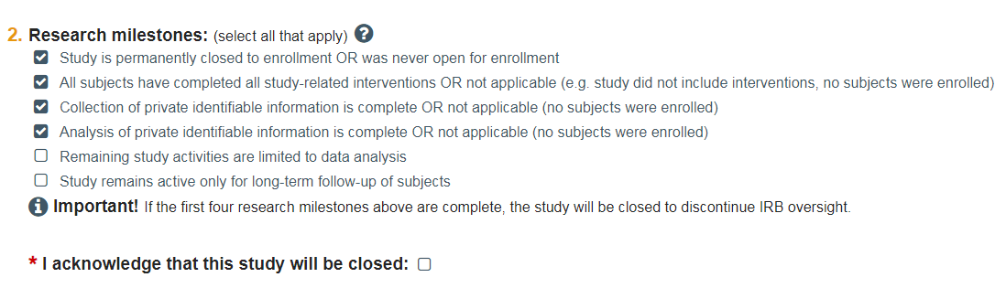
- Once the submission smartform has been completed, you will be redirected to the Close Out workspace. Important: On close out workspace page, please be sure to click “Submit” on the left side of the page (must be submitted by the PI). Your close out will not be submitted to the IRB if you do not click “Submit”. To double check that the close out has been submitted, the study status should note that the submission is in Pre-Review.
