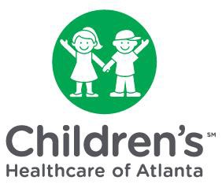
Physician Groups Included In Children’s
Financial Assistance Program

Children’s Healthcare of Atlanta at Egleston - Emergency Medicine
Children’s Healthcare of Atlanta at Scottish - Emergency Medicine

